**2010 Starting Dates**

The school year for 2010 will commence on Thursday 28th January for students in Years 1-6.

Kindergarten students will start on Friday 29th January.

School staff will have a development day on Wednesday 27th January.

**Classes 2010**

Students will be temporarily placed into their new classes for the first two weeks until numbers and staffing arrangements are confirmed.

**Important Dates and Reminders**

|  |  |
| --- | --- |
| ES1 and Stage 1 End of Year Activity – Movie | Wednesday 16th Dec |
| **LAST DAY OF THE SCHOOL YEAR** | Wednesday 16th Dec |
| **2010** | |
| Staff Development Day | Wednesday 27th Jan |
| **Students in Years 1 to 6 return to school** | **Thursday 28th Jan** |
| Kindergarten students begin | Friday 29th Jan |
| School Swimming Carnival – Stage 2/3 and eligible Year 2 students | Monday 1st Feb |

**Photographs**

Order forms are available from the school office if you would like to order a sports photo or school leader’s photo.

The deadline is tomorrow Wednesday 16th December.

**Year 3 2010 Bus Travel**

All Year 2 students were given a bus application form earlier this term in order to be eligible to for bus travel as they move into Year 3 2010.

Forms need to be returned to school by tomorrow for processing and new bus passes will be sent out in January.

**Helpers Morning Tea**

School staff catered for a morning tea today to thank our wonderful parents, carers and grandparents who help out with school activities throughout the year. Your support of the school helps make Wallerawang School a great caring and learning environment and the students enjoy having family members participate in classroom activities, Easter hat parades, book week, sporting events, canteen, education week open days, excursions etc. We look forward to your continued support in 2010.

**C:\Documents and Settings\rebecca.christie\My Documents\My Pictures\Microsoft Clip Organizer\j0434475.wmf**











Visit the school website at:

[www.wallerawan-p.schools.nsw.edu.au/](http://www.wallerawan-p.schools.nsw.edu.au/)

to view the newsletter in full colour!



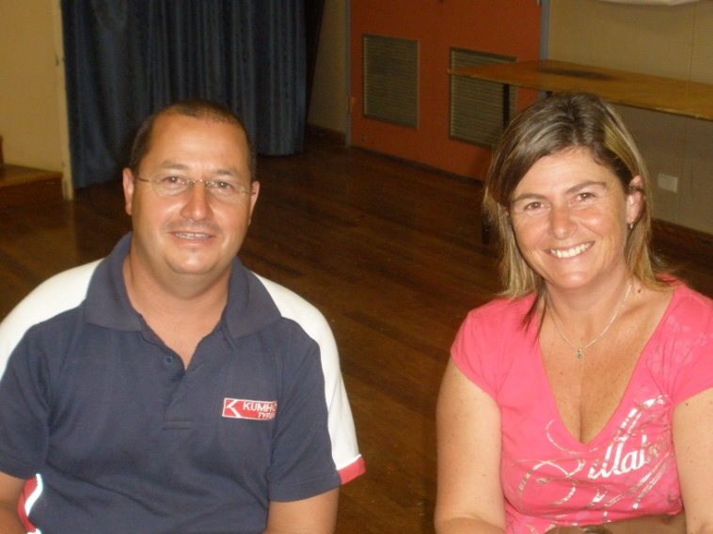



**Canteen Roster 2010**

|  |  |
| --- | --- |
| Thur 28th Jan | M. Carlisle, A. Seymour |
| Fri 29th Jan | A. Whyte, S. Giles, J. Wittingslow |
| Mon 1st Feb | N. Neale, K. Sonter |
| Tue 2nd Feb | T. McMillan, S. Beecroft |
| Wed 3rd Feb | J. Clark, M. Miles |

**Community Announcements**

**Mu Yeh Taekwondo**

Do you want to improve you self esteem self confidence, self discipline and general fitness?

Learn the exciting Martial Art and Self Defence system of Taekwondo! We cater for juniors, seniors, or the whole family! Mu Yeh Taekwondo specialises in streetwise women’s and children’s self defence. For more information contact Head Instructor Steve Ashbridge, 5th Dan Black Belt, on 6355 7675 or 0409305327. Classes are on Monday and Wednesday at Wallerawang School Hall. You can also visit the website at:

[www.muyehtaekwondo.com](http://www.muyehtaekwondo.com)

C:\Documents and Settings\rebecca.christie\My Documents\My Pictures\Microsoft Clip Organizer\j0092679.wmf

Good Luck Year 6 2009



Goodbye!